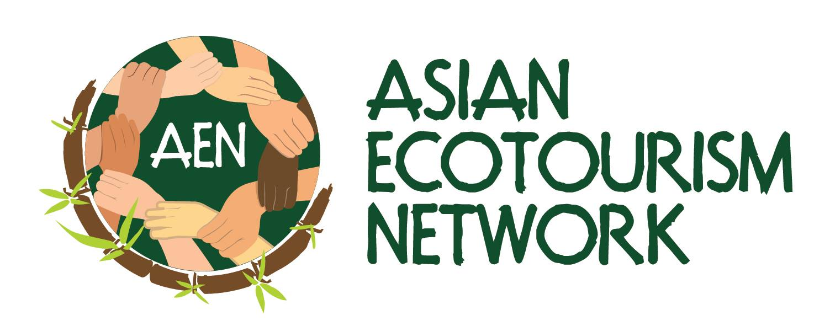 | APPLICATION FOR MEDIA PARTNERSHIP/ACCREDITATION

This is only an application and does not guarantee partnership. At least three articles on AEN per year should be committed for media partnership consideration.

1. AIM
Media Request (Partnership/Accreditation/Others) | Commencement Date

2. DETAILS OF APPLICANT
Media Organization & Address (Registered Office)
Type of Media & URLs
(TV, Online TV, Newspaper, Magazine, Radio, Online Radio, Online News or Blog)
Name As in Passport /Identity Card

Designation
(Editor, Publisher, Reporter, Journalist, Travel Writer, Producer, Broadcaster, Photographer, Blogger etc)
Nationality | Place of Residence
Office Phone | Mobile Phone
Email | Website
Gender | Professional Media Card Number
Editor Name | Editor Contact
Describe Your Interest with AEN
How Would You Like AEN to Reciprocate Your Involvement?
Provide A Short Biography of Yourself or Attach a CV

3. MEDIA COVERAGE
Circulation / Readership / Listeners Demographic & Geographical Coverage
Angle of interest for coverage

Please provide as much information as possible to help us assess your application. We would require at least two article samples or links to your articles written on ecotourism/responsible tourism/sustainability to be attached/included in your application as Annex. Also provide a scanned copy of your media card (where available) as Annex.

Please complete all details and forward to: MALLIKA NAGURAN mal101gaia@gmail.com

AEN USE ONLY

 | Name & Date | Comments
Supported
Approved

